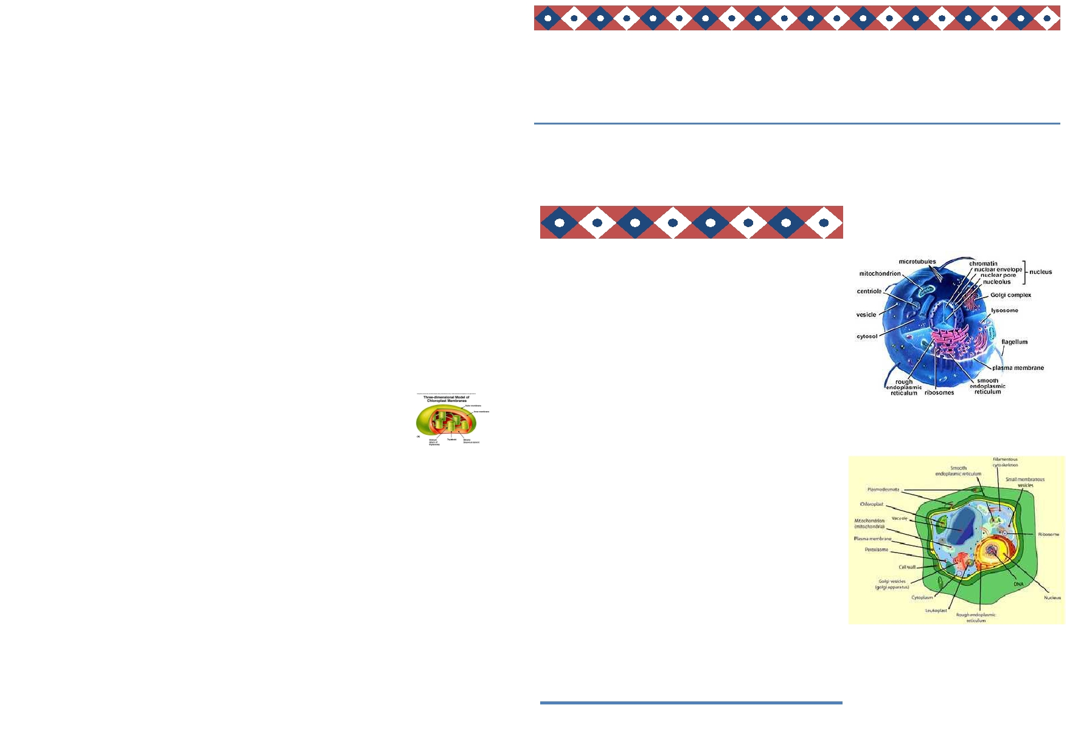
Chloroplasts
gy Ezra Splaver

Ezra: No way! It's a chloroplast! I'm your biggest fan! Can I interview you?
Chloroplast: Sure, but can we do this interview outside in the sun?
Ezra: That's fine, but why in the sun?
Chloroplast: Because I need the sun to conduct photosynthesis. When I receive
Inside the Cell

Volume 1, Issue 1
October 30, 2011

rays from the sunlight, I am able to create sugars and oxygen.
Ezra: That's so cool! I would like to make sugar! How can I be like you?
Chloroplast: I'm sorry, but that's not possible. You would need to have the same structure as me.
Ezra: I don't understand
Chloroplast: Well… I am a double membrane organelle, which means that I
have an outer and inner membrane. Between the two membranes is the inter
membrane space. The material that is inside of me is called the stroma, which is
Welcome to our first issue of Inside the Cell.

Inside this issue:

similar to cytoplasm. Within the stroma are thylakoids. A thylakoid is in the
shape of a flattened disk and is a membrane bound compartment in which pho- tosynthesis occurs. Since you aren't made up of thylakoids, you cannot produce sugar.
Ezra: I thought inside the stroma there is something called
granum.
Chloroplast: Yes, a stack of thylakoids is called granum.
Ezra: I have one more question. What class of organelles are you in?
Chloroplast: I'm in a class called Plastids. Plastids are found in cells of algae
and plants and often contain pigments used in photosynthesis. For example, I have the pigment, chlorophyll, which is the reason why I'm this green color.
Ezra: It was nice meeting you, chloroplast. Thank you for answering all of my
questions.

Thank you to all our reporters for their wonderful stories.
Look for our next issue of Inside the Cell
Membrane and cytoplasm

Nucleus/Mitochondria

Golgi/Ribosomes

Endomembrane System/

Lysosomes/Vacuoles

Cytoskeleton

Cell Wall/Cell Junctions

Chloroplasts
2/3

4/5

6/7

8/9

10/11

14/15

16/17

18

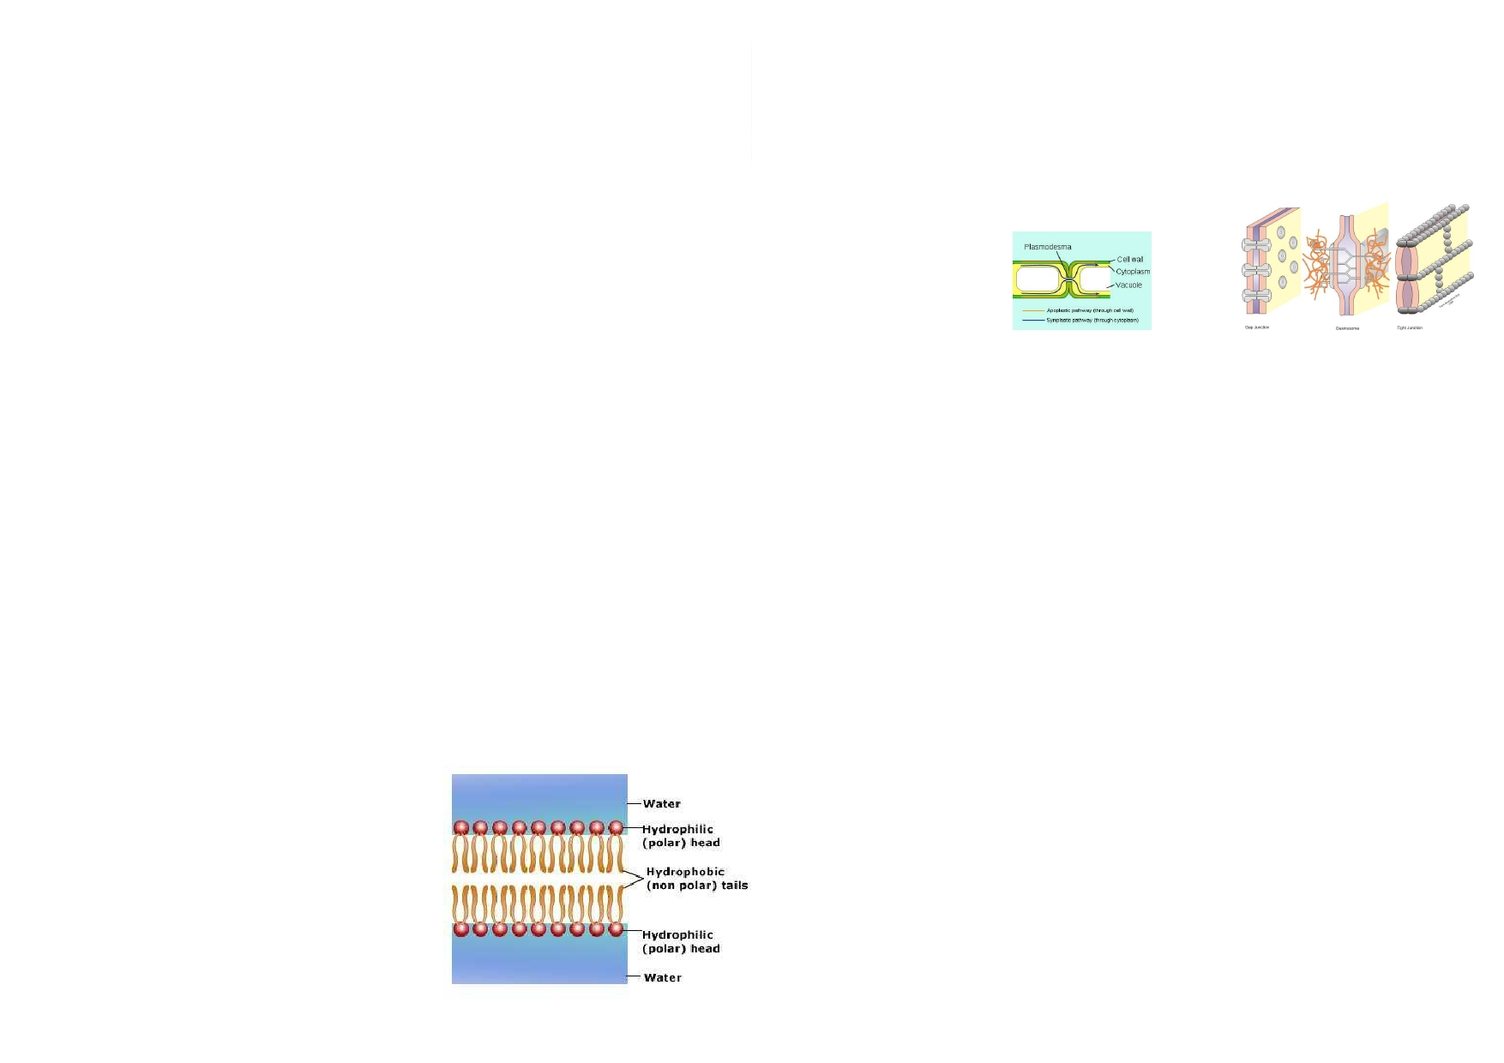
Let's Absorb Some
Membrane Facts
by Maia Groman

I work as a barrier for the cell, protect- ing it from the outside world. I sort of work as a crossing guard, with a selec- tive permeable lipid bilayer.

When I see a solid, macromolecule, or other large nutrient nearby that I think
will benefit the cell I perform some-
thing called endocytosis. I start to bend myself around the object and surround it. I form an invagination (type of de-
The Cell Junction
by Noah Light

Have you ever asked yourself "what holds a cell together?" We all know the basic cell celebrities, but what holds it all together? Well, we were determined
to find out and the answer was quite surprising. Two words: Cell Junction. Here is the interview, word for word.

I made of two layers of lipids and pro- formation) and bring the object into the
teins. One side of each lipid is hydro- cell creating a vesicle.

Q: Hello, we just saw you leave the cell, who are you?

phobic; scared of water and the other
side is hydrophilic liking water.
The opposite of this is called exocyto- sis. This is when I bring a large piece
A: It's my only break. Please don't bother me now.
Q: Are you the person who holds the cell together?

Throughout me there are also proteins. of waste outside of the cell. Most of the
nutrients that leave the cell through
Well, my job is to regulate what gets in exocytosis are hormones and amino and out of the cell and I do this in many acids.
A: All right you got me, the name is Cell Junction, but its not like anybody knows my name.
Q: So what exactly do you do?
A: Well, I bind cells together. Though, I only do animal cells, not those nasty

different ways. Some of them require
energy, active and others don't, pas- sive.
Mediated transport is the way I trans-
port nutrients, sugars, and amino acids.
These molecules travel in and out
plant cells! Do you think any of the cells could operate without my help?
Q: Well I guess not, can you tell us more?
A: When I do the job nothing leaks out, not at all. I put the coat over everything

What are the different ways this hap- through small passageways in my lipid so it is safe. I make three different types of bonds: Adherens junctions, Gap

pens?
There are many.
Diffusion is when molecules and ions, like carbon dioxide, oxygen, and water, go through me and doesn't require any energy on my part.
Osmosis is like diffusion although it is limited to water. During osmosis I the, the plasma membrane let water through me so that the amount on the inside and
outside of the cell is equal. Once this occurs water continues to flow back
and forth, but at a symbiotic rate.
bilayer. I am very picky about how I do
this and it does not occur often.
junctions, and Tight junctions. I usually bind two cells together, but sometimes I bind a cell and an extracellular matrix.
Q: What more do you do to help out?
A: I can also let materials pass through a small gap, which without, the cell
would be in trouble. I pretty much just use protein complex and I'm set to go.
Q: Do you know any of the big stars of the cell?
A: Yes, they are all jerks, my only other decent co-worker is plasmodesmata. He pretty much does the same work as me but for plant cells.
Q: Okay I think this interview is over thank you for speaking and…
A: No!!!!!! I just want some recognition!!!!!!!! I mean cmon nobody even knows
who I am! I mean seriously…
Q: Goodbye!!!!!!!!

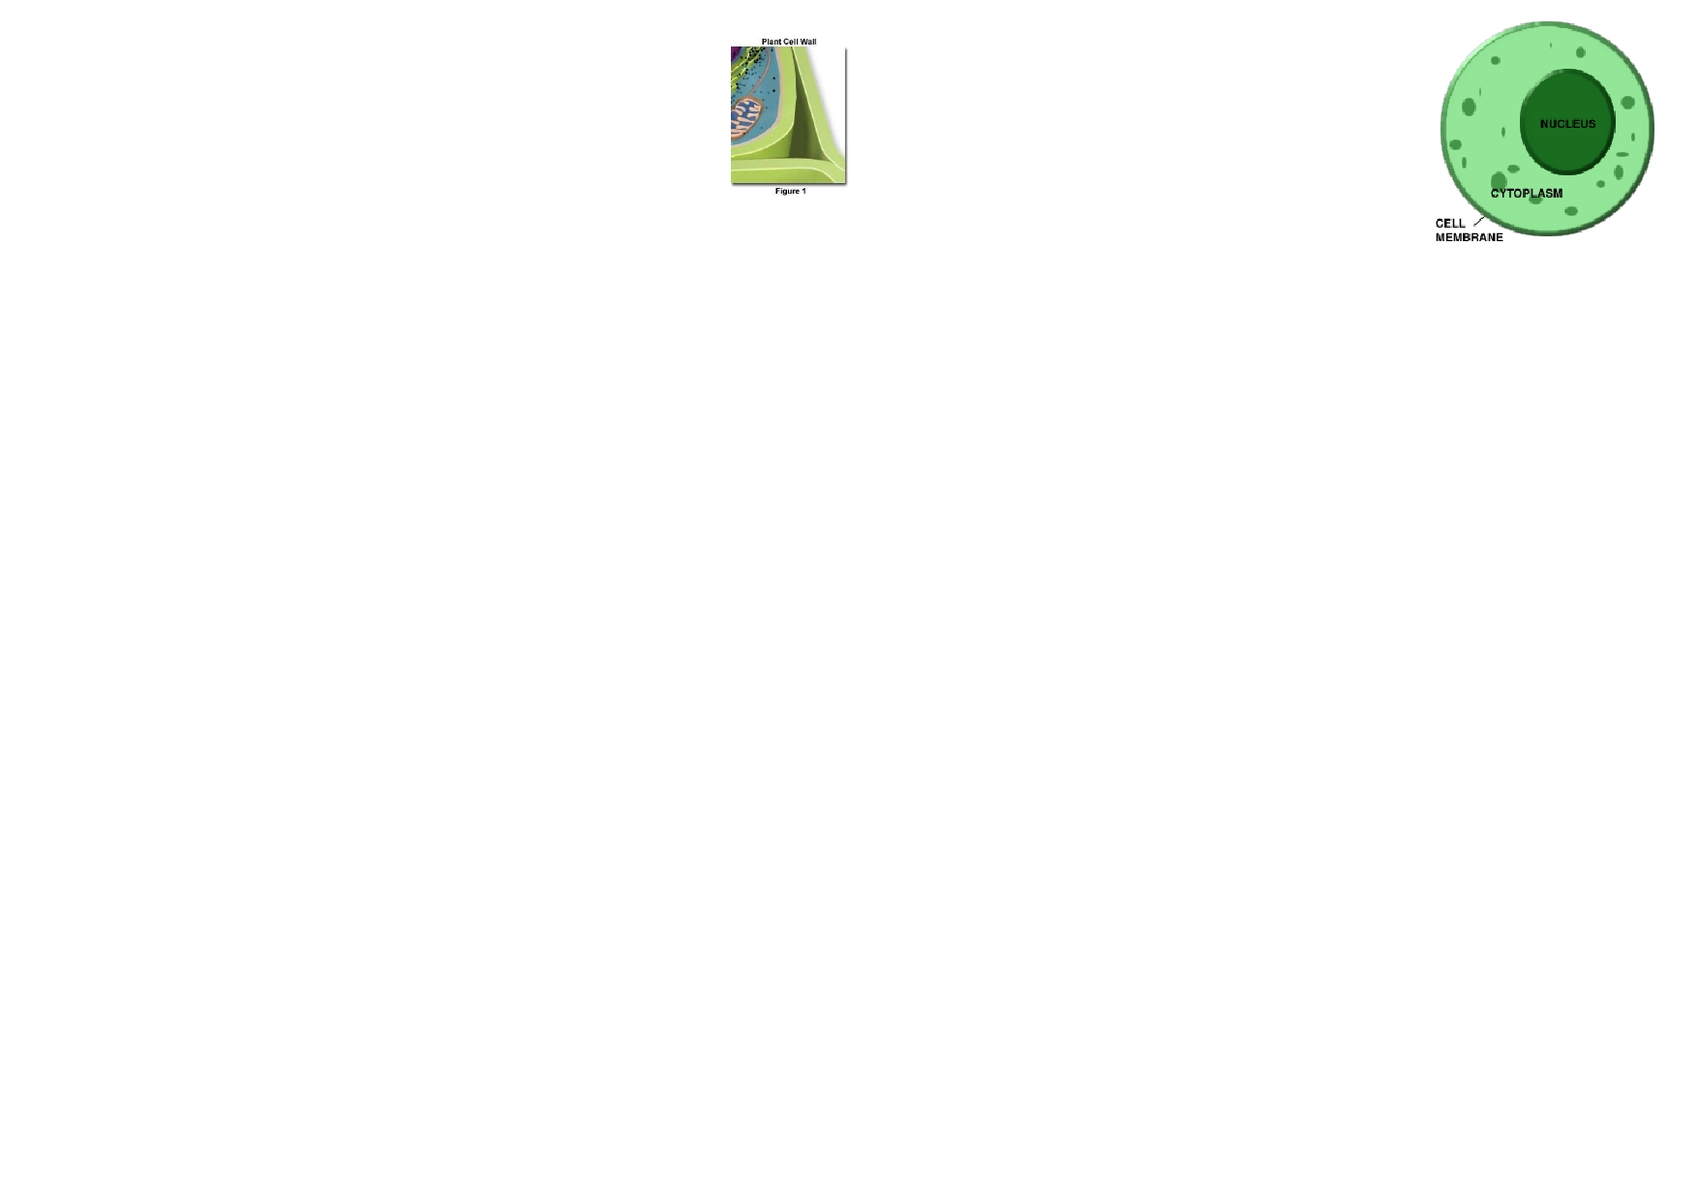
The Cell Wall
by Dani Ditchek
Dani: Hello. I have the great honor of meeting with the famous Cell
Wall, Cornelia. With one of the very important jobs in the cell, she will
explain to us what exactly she does, and why she is so important in a
cell. Let's begin!
Dani: So Cornelia, what is your main job in the cell?
Cornelia: First of all, thank you so much for having me here today. I have a
very important job in which I protect the entire cell, hence the word "wall." I
also help maintain the cells shape as a whole.
Dani: That is very interesting. Thanks to you, the cell does not fall apart. Let's
continue. Where are you located in the cell?
Cornelia: Well, in the cell I am located external to the plasma membrane. How-
ever, I am also found in cells, which are located in plants, bacteria, fungi, and
some protists.
Dani: Plant cells eh? I hear that there's some kind of difference between the
plant cells and other cells. Care to explain?
Cornelia: Yes. You must understand that plant cells have a cell wall like me.
Other eukaryotic cells, like animal cells, do not.
Dani: Are all the cell walls in all plants the same?
Cornelia: No. Many plant cells have a 2-part cell wall. This means that a pri-
mary cell wall is laid down first, and then a secondary and more rigid wall lies between the plasma membrane and the primary cell wall.
Dani: You mentioned that the secondary cell wall is "more" rigid. Is the pri-
mary wall that is found in other cells also rigid?
Cornelia: A cell wall is fairly rigid, but the secondary wall is more rigid. Being
rigid also helps maintain the shape of the cell.
Dani: What holds the cell walls of adjacent plant cells together?
Cornelia: The middle lamella, a sticky substance on the outside of cell walls. Dani: Alrighty, here's the last question of the day. Do you enjoy being a cell
wall?
Cornelia: I absolutely love my job! It's interesting, important, and fun all at the
same time. There is nothing that would make me happier.
Dani: That's wonderful. Well, thank you so much for using your time to come
Q&A With Cytoplasm!
by Avi Alpert

Cytoplasm is the protoplasm, or all of the
materials within a cell membrane, excluding the nucleus.

Q) What is your main function in the cell?

A) I don't have only one specific function; the organelles and
materials inside me have their own functions. For example, one
organelle called the endoplasmic reticulum has the function of transporting proteins throughout the cell.

Q) What materials are you comprised of?

A). I am comprised of cytosol, which is a jelly-like liquid, the cy- toskeleton, and other various organelles.

Q) What makes up the cytosol in a cell?

A) The cytosol is made up of mostly water with some other chemicals such as proteins, dissolved ions, and many more.

Q) Are you prominent in both eukaryotic and in prokary-
otic cells?
A) I am existent throughout both types of cells, but there is a differentiation. In a eukaryotic cell, the materials inside of me are divided into different membrane-bound organelles, which
have their own function. In prokaryotic cells, I have no individ-
ual membrane-bound organelles. All of the processes and the functions of the cell occur all over me.


Nicole the Nucleus: Diva of the Cell
by Hannah Katz/Daniella Cohen
\
Boca Raton, FL - Here today, we're lucky enough to have the chance to speak with Nicole the
Nucleus! For years, she has been a crucial part of the cell media. Without this lovely organelle,
the cell would not be able to function as well as it does. Oh, here she is now!

Me- Hey Nicole the Nucleus! How are you?
Nicole - Oh, great, thanks! Just a little bit tired. As you know, I have a major job. Me- Would you mind explaining to readers exactly what you do on a daily basis?
Nicole- No problem! Well, folks, I'm pretty much the center of all cell activity. I control gene
expression and control the cell's actions by directing protein synthesis.
Me- Wow! That sounds pretty tough!
Nicole - Well, I do have lots of help. I have a great support system to keep me functioning.
They're called my nuclear envelopes. They help control what gets to me and what possible dan- gers I should keep out. It separates me from the rest of the cell so I can focus on my job.
Me- But if these membranes are so thick, how does anything get pass them?
Nicole- They have really great helpers called pores which decide which substances and materials
can get through my thick exterior. They can transport and export genetic substances that I pro-
duce.
Me- What do you mean by genetic substances?
Nicole- Before a cell divides, I contain chromatin which is a long fiber made of DNA and pro-
That's all my questions for the Cytoskeleton group as a whole. I think it is time
for individual interviews.

Reporter: Mr. Microfilament, what are you made out of and what is your func-
tion?
Microfilament: We are made out of two intertwined strands of Actin subunits
formed into a rod-like shape. Our functions are maintaining the cell's shape by a pulling force, allowing cells to change its shape when necessary, like in muscle contraction. We also act as tracks for the movement of Myosin molecules.

Reporter: Describe the average Intermediate Filament.
Intermediate filament: Well, we are about 10 nanometers in diameter, shaped in
rope-like strands, and we are stronger that actin filaments. We also like the Micro
Filaments, maintain shape by bearing tension, or pulling. Imagine a stick, when
you try to bend it, it keeps its shape by pulling against the force you are exerting. That is how the Intermediate Filaments maintain the Cell's shape. We also anchor the Nucleus and other organelles to their spots, so that they will not move.
Some things inside the Intermediate Filaments are:

teins to aid in the process. But, when the cell is in mid- division, the chromatin coils and con-
denses to form chromosomes. Now, because of me, another cell is created! By the way, you can see my chromosomes with a light microscope.
Me- That's fascinating! You're so good at what you do. A source has revealed that you contain a
prominent structure called the nucleolus. Want to explain what that is?
•
•••
Keratin, found in skin, hair, and nail cells
Vimentins, a common support for many cells
Neurofilamints, found in neural cells
Lamin, structural support to the nuclear membrane.

Nicole- Of course! So, the nucleolus is the best! Like my right-hand-man, living in my center!
Anyways, I produce the ribosomes to control the cellular DNA. The nucleolus's job is to produce ribosomes so I can do my job.
Me- So i assume ribosomes exit you via pores?
Nicole- That's right!
Me- I've also heard about RNA, tell us, Nicole, about your role in that?
Nicole- Well, picture me as the controller of everything. I produce the DNA which holds the in-
structions for the RNA. RNA then carries out my directions; you know, like a chain. From me to
DNA to RNA which leads to the success of the cell!
Me-Wow! I think you have your work cut out for you! Why don't you go back to your job.
Thanks so much for your time, Nicole!
Nicole- Sure thing! Thanks for hosting me.
Me- And THAT, folks, is what really occurs behind the scenes in the nucleus.
Reporter: No wonder nails bend like a stick and are hard to break, but most
women would disagree about the second part.

Reporter: Mr. Microtubule, what are you made out of? How big are you?
Microtubules: We are about 23 nanometers in diameter, we are shaped in a hollow tube, and we are comprised of Alpha and Beta Tubulin.
Reporter: What are some of the Microtubule's functions?
Microtubules: Well, we make the flagella and cilia so one might say that we allow for cell transportation, we move chromosomes and other organelles to where they belong during cell division, and make cells stiffer by further anchoring the organ- elles. Also, we allow for synthesis of the cell's wall in plants.

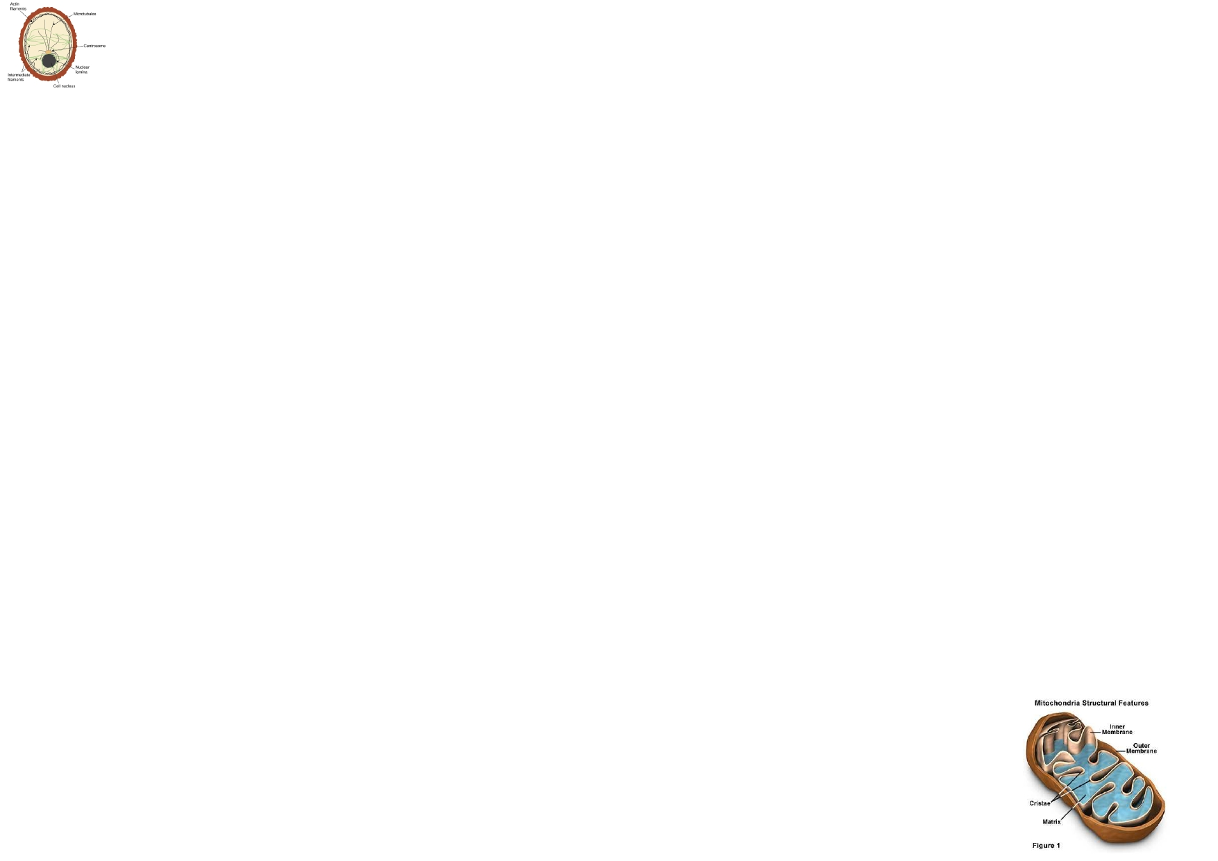
The Cell's Cement
by Moshe Markowitz

Standing right beside me is the Cytoskeleton group. Made out of long
protein strands, the Cytoskeleton maintains the cell's shape as a skeleton would to a body; hence the prefix Cyto meaning semi fluid component of a cells mem-
brane, and a skeleton meaning maintains shape. It has many other functions like— actually I will let them speak for themselves, so here they are, the cy-
toskeleton group!
Let me introduce Mr. Microfilament, Microtubule, and Mrs. Intermediate Fila-
ment.
Reporter: So may I begin?
Cytoskeleton Group: you may.
Reporter: What are your main jobs as the cytoskeleton?
Cytoskeleton Group: We have 4 main functions. First of all, we organize the
cell's structure. In other words, we keep all the organelles where they are sup-
posed to be. Next, we maintain the cell's shape and the same dimensions that it is
supposed to be. We know how to keep things in rod shapes, circular shapes and even spiral shapes. Another function of ours is that we help cells and organelles move. For example in cell division each organelle must be in a specific location at each phase, and the Cytoskeleton helps with transporting them there.
Microtubule: others like me can come together to make a flagella or cilia to allow for cell transportation.
Cytoskeleton Group: Our final function is that we have a major role in cell signal-
ing. Cell signaling is when information is passed through the plasma membrane and into the cell. We help bring that information throughout the cell into the nu- clear envelope through the nucleus's pours.
Reporter: Wow! It seems you have major jobs to accomplish inside the cell,
what would the cell do without you?
Cytoskeleton Group: Actually, this does not happen we are in all known cells, but
I guess if there was one without a cytoskeleton then:
-The cell would lose its original shape
-The cell would remain stationary
-Cell division would not be possible
-The organelles would not be organized, disabling the cell to function
-The cells would remain unknowing of the cell next to it and if they are in the
Yesterday, we sent our reporter Moshe Weiss to interview
Mr. Mighty Chondria (mitochondria), who was the star of lasts week's installation of Organelle Weekly. Here's how it
went:

Moshe: Hi Mighty. I have a series of fan-submitted questions to ask you today. MC: Fire away!
Moshe: Ok. So where do you live?
MC: Inside of any animal or plant cell, within the cytoplasm.
Moshe: Have you lived there your whole life?
MC: No. I used to be my own independent organism and that's why I am one of the only organelles with DNA.
Moshe: WOOOOOOOOOAH… So, on an average day, how
many layers do you wear?
MC: Well, I always wear two layers. Between the two layers is a
space. The second layer is all folded, and the folds are called cris- tae. The cristae are there to provide more surface area for a fluid
called mitochondrial matrix. Mitochondrial matrix breaks down
the chemical energy of food and converts it to ATP, which pro- vides most of the energy for cellular work.
Moshe: So basically you're the powerhouse of the body? MC: Yup.
Moshe: Well, thanks for joining us today.
MC: My pleasure. Until next time!

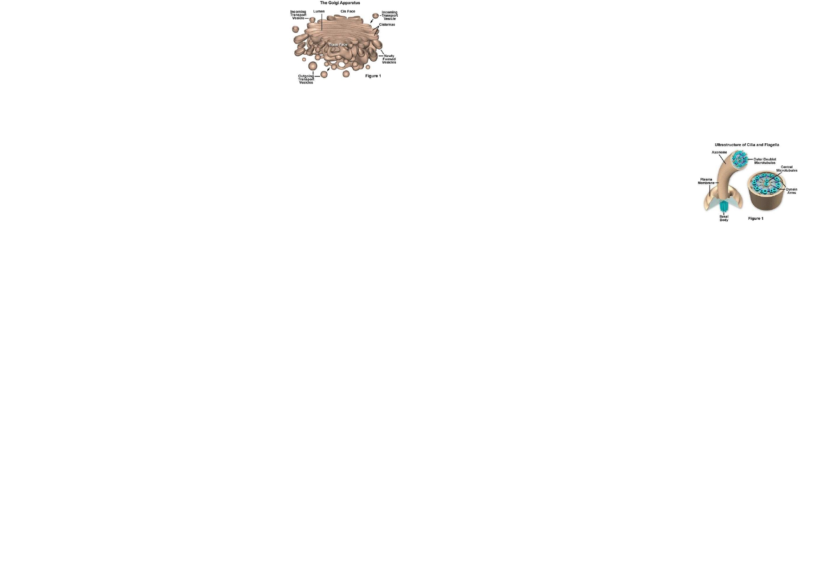
THE CELL'S FACTORY
by Brett Wolff

Introduction: Here with me today I have the privilege to inter-
view a cytoplasmic organelle, the packaging and transporting part
of the cell, Mr. Golgi Apparatus.
Brett Wolff: It's a pleasure to be interviewing you today Mr. Golgi Apparatus.
Golgi Apparatus: Oh it's an honor to be here. I just hope the Golgi filling in for me in my usual cell isn't having any trouble packaging and transporting without me.
BW: Is that your function? Packaging and transporting?
GA: Yes sir, it is actually a very interesting job.
BW: It does sound interesting. What exactly do you do?
GA: I transport vesicles from the ER fuse on one end of the Golgi stack.
BW: That seems like a tough job!
GA: Yes it is, and I do all of this to form flattened sacks called cisternae
BW: But if all of this happens in one end of the Golgi, then what happens in the other
end?
GA: The substances that are processed and packaged are given off at the other end.
BW: And then what?
GA: Well then the substances are released in transport vesicles.
BW: Does this form anything in the body?
GA: By adding sugar to these packaged substances, glycoprotein is formed.
BW: What happens to these proteins?
GA: They are then processed, pinched off into vesicles, and released into the cytoplasm for cell use.
BW: And then what? What do these proteins do?
GA: They become membrane proteins that will be transported someplace else in the cell.
BW: What else do they do?
GA: Well they are also stored inside vesicles until released through plasma membrane.
BW: If you don't mind me asking, where in the cell are you located? GA: I'm located near the nucleus of the cell.
BW: That's very interesting! One last question, what exactly is your structure?
GA: Well my structure is made up of cisternae which are flattened stacks of membrane. BW: And how does the cell benefit from these cisternae.
GA: They help proteins travel from different points in the cell using enzymes.
BW: Wow! All of this is so interesting! It's been so wonderful interviewing you today, and I have learned so much about you.
GA: Oh it was my pleasure. Thank you so much for having me!

Interviewing Cilia and Flagella
By Kayla Petrover
Cilia and Flagella, very important eukaryotic organelles, help with
processes from the respiratory system to creating a new child. With
their similar structures, they are both part of the undulipodiumuse
group. Cilia and Flagella have participated in an exclusive interview
telling us about themselves and exactly what they do behind the scenes.

Kayla Petrover: Cilia, you are vital to a human's
survival, right?
Cilia: Well I'm in every human body so probably
yes.
KP: Wow, nice. How would you describe your appearance?
C: Flagella and I are identical in build in eukaryotes, but we differ in
sizes based on our functions. We look kind of like tails attached to
cells. Though I can live alone or in clusters based on my type. In
clusters, I look like a bunch of tails coming from a surface— almost like a sea anemone.
KP: Beautiful. Now you mentioned that your size changes based on
your function. What are your functions?
C: Thanks. Well I have two forms: motile cilia and primary cilia. I act
as a sensory device and help move mucous, fluids, and other materi-
als over cells. For example as motile cilia, I line the entire human tra- chea to clear the dirt and mucous away from the lungs. Differently as primary cilia, I am just one cilium attached to nearly every human cell and I act as a sensory antennae.
KP: Interesting. It was great speaking with you! Flagella, you also
are very important. What do you look like?
Flagella: I have three different types: bacterial, archaeal and eu-
karyotic. I'll speak about my eukaryotic form, though I also live in
prokaryotes. As Cilium has told you, I look kind of like a tail attached

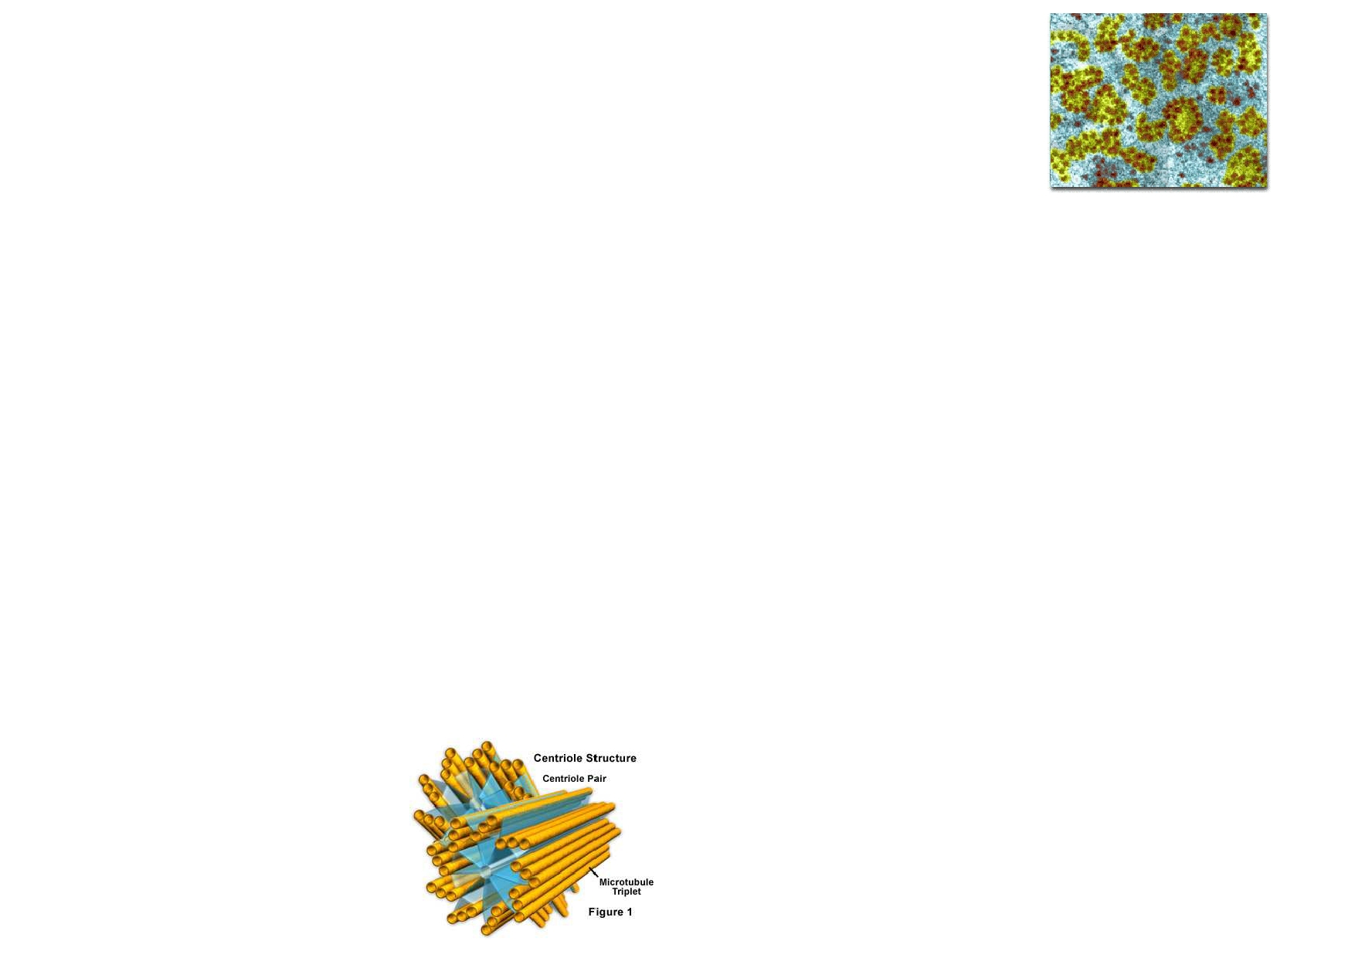
The Centriole

by Cherie Landa
I had the amazing opportunity to interview one of the lesser known parts of the cell,
the centriole.

Cherie: "So even though most people don't know of you, you're job in the cell is very
important, right?"
Centriole: "Of course. I play an active role in cell division, without which chromosomes
would not be able to move during the cell division."
The centriole are found to be a part of spindle fiber formation to separate the chromosomes during cell division (mitosis).

Cherie: "Your role in the cell is so essential... I wonder why so many people don't
know about you."
Centriole: "Well that's probably because I'm located near the prominent nucleus, so
people don't really notice me in comparison."
(Centriole can be found in the cytoplasm near the nucleus when it is not
aiding in cell-division.)

Cherie: "How would you describe yourself in appearance?"
Centriole: "I look like 2 empty cylinders, positioned at right angles to eachother. There
are two of me-- I come in pairs. Right before cell division two new centrioles are
formed though."

Cherie: "Interesting... But why pairs? Why can't there just be one of you?"
Centriole: "That's because of Celiogenesis."

Cherie: "...And what's that?"
Centriole: "Its the process of forming the cilia and
flagella. The centrosome (four centriole) divides and
travels to form the basal body from which the cilia
and flagella originate."

Cherie:"Thank you for your time!"
Ribosomes
by Hod Marks

On November 11th 2011 a new original motion picture will
be playing in all local movie theatres. Ribovid Organpiper, an award-winning actor, will be playing the lead role of the movie. He was invited to the Harry Miller Show for some questions and answers regarding his acting role in this new movie.

HM: Good evening Ribovid, thank you very much for joining us tonight.
Ribo: My pleasure. Please, call me Ribo.
HM: All right. So, Ribovi...I mean Ribo…. Now that you will be starring in the all-new motion picture "The Cell" can you tell us
about your part?
Ribo: Well I'll be playing as the most abundant organelle in the cell—which is funny since it has the same name as me—the Ri- bosome.
HM: Wow! And…what will you do as this organelle?
Ribo: I will receive instructions from DNA, a friend of mine in "The Cell", to construct proteins through the process of protein synthesis.
HM: And where exactly will this whole scene be taking place?
Ribo: I will be playing my role either when I'm "attached to the ER", or when I'm "floating around in the Cytoplasm".
HM: Fascinating!
Ribo: It truly is, I'm very lucky to be part of this project.
HM: Well, I'd like to thank you for coming along all the way from Hollywood at such short notice.
Ribo: Oh it wasn't a hassle don't worry about it. Thanks for
having me! Have a good evening! GOOD NIGHT NEW YORK!

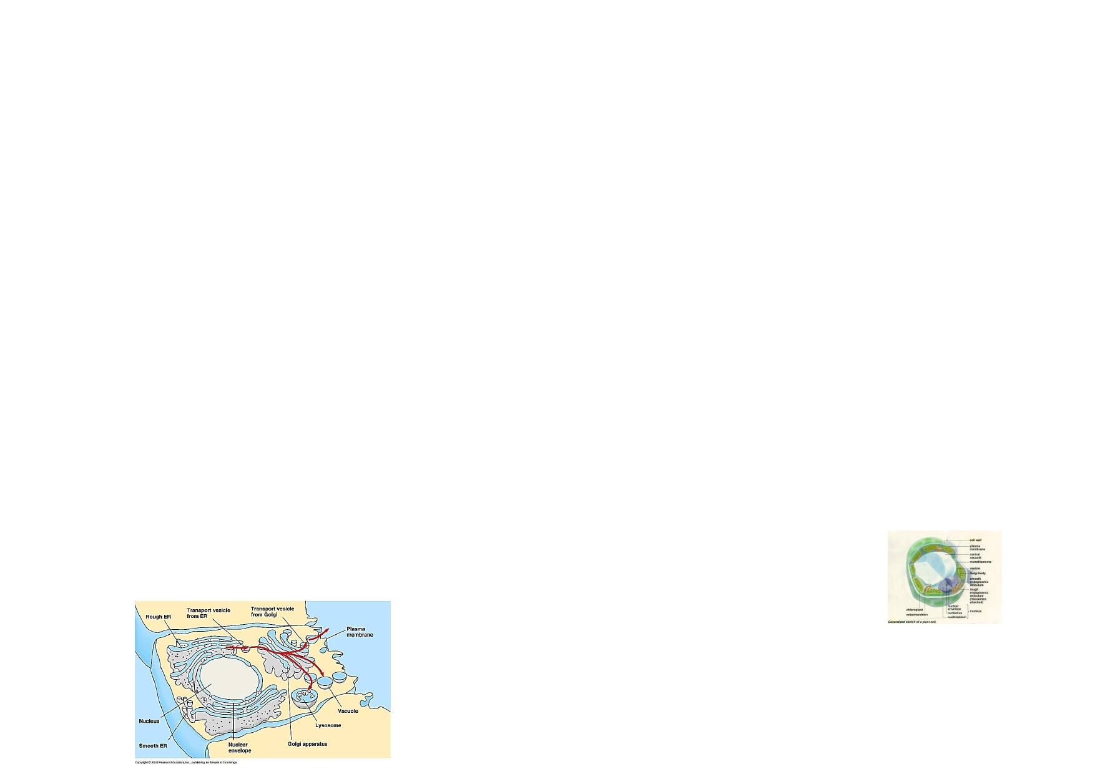
The Endomembrane system
Yitzchak Kaminetsky 9H

Interviewer: So, Endomembrane system, I have heard a lot about you
and your role in the cell, what exactly are you?
Endomembrane system: I am a system of internal membranes in eu-
karyotic cells that divides the cell into functional and structural com-
partments, or organelles.
Interviwer: Interesting, What do you consist of?
Endomembrane system: Well, some of the different parts in me are
the rough Endoplasmic reticulum (ER), the smooth ER, the Golgi ap-
paratus, and the vesicles and plasma membrane.
Interviewer: What do they all do?
Endomembrane system: They all work together to transport cellular
materials.
Interviewer: And what are some of your functions in the cell?
Endomembrane system: Well, I take care of the synthesis, storage,
and export of molecules of molecules, I renew organelles of cells by
decomposition, and I divide the cell into different compartments.
Interviwer: If you could paint a picture for us, where would you be
located in relation to the other parts of the cell?
Endomembrane system: Everything you see here. You'll see every-
thing that is in me here. The Smooth and Rough ER, the Golgi appa-
ratus, etc.
Exclusive interview with the cell's famous vacuole!!!!!!
By Jessica Griff

In a recent interview with the vacuole, I got the inside scoop of its ultimate
functions and characteristics and its contribution to the cell. Let's hear from her
herself and see what she says about her job…

Are you located in both the animal and plant cell? Yes. In fact I make up about 50-90% of a plant cell

What do you consist of?
Mostly water plus dissolved sugars, salts, proteins, and other nutrients

Do you have a membrane?
Yes it has a single membrane

Now tell me, do you have a specific characteristic/job?
I actually do not. I come in many different shapes and sizes and have a variety
of functions.

You say you have various functions, can you name one?
I collect excess water and the hub releases it to the outside. In plant cells, I
store chemicals, starch, and pigments

What is plastid?
It is located in the plant cell, and it's a vacuole that stores pigments, sugars, and
starches. Because of the pigments stored in the vacuole, flowers are able to have such pretty and vibrant colors.

Without you, will the cell survive?
No I am a vital part to the cell

Why won't it survive without you?
If I were not present in the cell then the cell's fluid would become too dilute to
support life. The cell would eventually burst

Wow that sounds like a fun job! You must me so crucial to the cell! Thank
you for your time. I have sure learned a lot!

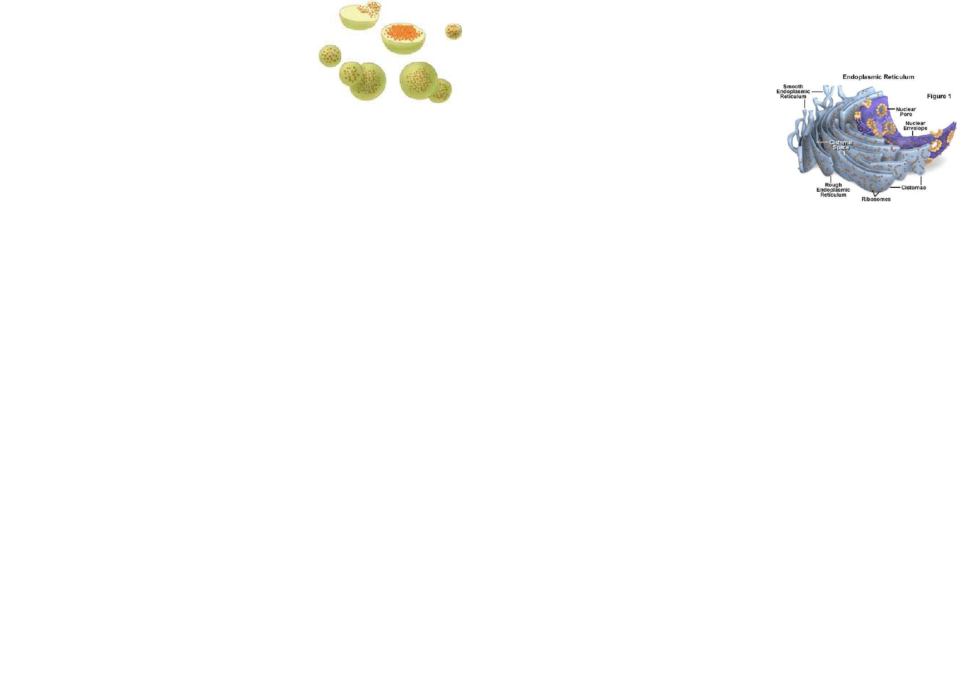
Lysosomes
by Jonathan Attias

20 Century Fox has just announced of their new th
A special interview with the Endoplasmic Reticulum
by Jordan Stauber

documentary on the cell. We got to speak to some of its main characters, and this is what they had to say.
Jonathan: So, Lysosome, what role do you play in this documentary?
Lysosome: Well, I am actually going to play myself in the movie, so I'm very excited about that.
J: Great so what were some of the things you had to do?
L: As you know, I can be found in most animal-like eukaryotic cells so I will be
doing a great deal of acting in this upcoming film. In addition, I had many
scenes in which I used the enzymes inside of me to digest food or dead cells.
J: How would you describe yourself as an actor?
L: I like to think of myself as a vesicle that holds the enzymes, which break down other cells when they die. I am also a single-membrane organelles.
J: Can you tell us a bit about your background?
L: The enzyme inside me came from the endoplasmic reticulum, and then they
were packaged and sent to the Golgi apparatus. Then I got my digestive enzymes
from the Golgi apparatus and I moved to the cytoplasm in the cell until I got a call telling me I needed to digest a few food cells, which I did, and I was con- tacted by the producing company to act in their movie.
J: So what would happen if you were missing enzymes?
L: Good question… First I would fill up with indigestible substances and even- tually I'd interfere with other cellular functions.
J: If such a thing should happen, what would be the worst-case scenario?
L: Pompe's disease would cause the lack of glycogen-digesting cells in the liver,
and Tay-Sach's disease would cause a lack of lipid-digesting enzymes in the brain.
J: That sounds horrible… When are these conditions most fatal?
L: These conditions are most fatal in early childhood but the problem is that they are a genetic disorder and therefore cannot be prevented.
J: Well, thank you Lysosome, it was nice to have you and to hear so much

What is your name?
My name is Endoplasmic Reticulum.
What do you do?
I transport mostly protein throughout the cell. I have a fluid filled canal system. I have two
main parts; the smooth part and the rough part. Molecules are transported in vesicles to the Golgi Apparatus.
What is the difference between the SER and RER.
The rough has ribosomes, and the smooth part does not have ribosomes.

Well let's talk about your smooth part first; what does that do?
My smooth part has functions in several metabolic processes, including
synthesis of lipids and steroids, metabolism of carbohydrates, regulation
of calcium concentration, drug detoxification, attachment of receptors on cell membrane proteins, and steroid metabolism.
Where is your smooth component located?
It is located next to the nucleus envelope, and is found in both animal and plant cells.

Now tell me, What does your rough section do?
Well basically it synthesizes proteins.

Could you tell me more?
More detailed functions of my rough part are providing an internal structural skeleton to
support the cell's shape, as storage of the synthesized materials and minerals, such as calcium in myocytes, forming an internal network through which materials can be trans- ported; and providing a large surface area on which chemical reactions can occur.

I read something about a Sarcoplasmic Reticulum, could you tell me about that?
Oh, that is just a special type of Smooth ER found in smooth and striated muscle. The SR
stores and pumps calcium ions, while the SER synthesizes molecules.

